SQL CHECK, OPTIMIZE and REPAIR TABLE

🎯 Objective:
# Source: AI Source: Provided by: [Data Path: Persons Table -> ID Column: 1, Name_En Column: Motasem Essam] -> From: [ChatGPT] on [6/11/2026]
Learn how to check, optimize, and repair tables to maintain performance and data integrity in MySQL.

what is corruption or misalignment issues
Let’s break it down: When we say that a table may have corruption or misalignment, we’re talking about problems that affect the integrity, consistency, or internal structure of the table’s data and indexes on disk.

🛠️ What is Corruption?
# Source: AI Source: Provided by: [Data Path: Persons Table -> ID Column: 1, Name_En Column: Motasem Essam] -> From: [ChatGPT] on [6/11/2026]
Corruption means something went wrong with the data storage, making the table unreadable or inaccurate.

🔸 Causes of Corruption:
# Source: AI Source: Provided by: [Data Path: Persons Table -> ID Column: 1, Name_En Column: Motasem Essam] -> From: [ChatGPT] on [6/11/2026]
- Power failure or system crash during writes
- Disk failure or bad sectors
- File system issues
- Improper shutdowns
- Bugs in MySQL (rare)
- Incompatible storage engines or tools editing .MYD or .MYI files manually

🔸 Symptoms:
# Source: AI Source: Provided by: [Data Path: Persons Table -> ID Column: 1, Name_En Column: Motasem Essam] -> From: [ChatGPT] on [6/11/2026]
- Queries return errors
- Missing or incorrect rows
- MySQL crashes when accessing the table
- CHECK TABLE returns messages like Corrupt, Warning, or error reading table

🔧 What is Misalignment?
# Source: AI Source: Provided by: [Data Path: Persons Table -> ID Column: 1, Name_En Column: Motasem Essam] -> From: [ChatGPT] on [6/11/2026]
Misalignment usually refers to structural problems within the table’s indexes or data rows — especially in the case of MyISAM tables.

🔸 Example Situations:
# Source: AI Source: Provided by: [Data Path: Persons Table -> ID Column: 1, Name_En Column: Motasem Essam] -> From: [ChatGPT] on [6/11/2026]
- Indexes pointing to the wrong data rows
- Deleted rows not cleaned up properly
- Data not ordered correctly for index optimization
- Inconsistencies between index and data files

🔸 Why it Matters:
# Source: AI Source: Provided by: [Data Path: Persons Table -> ID Column: 1, Name_En Column: Motasem Essam] -> From: [ChatGPT] on [6/11/2026]
- Slower queries
- Incorrect results
- Errors on SELECT or JOIN operations

🧪 How CHECK TABLE Helps
# Source: AI Source: Provided by: [Data Path: Persons Table -> ID Column: 1, Name_En Column: Motasem Essam] -> From: [ChatGPT] on [6/11/2026]
When you run:
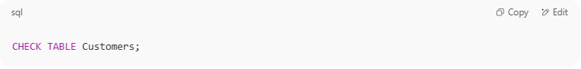
CHECK TABLE Customers;

MySQL checks:
- Table format consistency
- Whether rows and indexes are correctly linked
- Disk storage consistency (for MyISAM)
- Index tree validity (for InnoDB, to some extent)

🧰 If Issues Are Found:
# Source: AI Source: Provided by: [Data Path: Persons Table -> ID Column: 1, Name_En Column: Motasem Essam] -> From: [ChatGPT] on [6/11/2026]
- Use REPAIR TABLE (only for MyISAM)
- Use a dump + restore for InnoDB
- Check your hardware/logs if corruption is recurring

Would you like a simulated example of a corrupt table and how to detect/fix it?

🔹 1. CHECK TABLE
# Source: AI Source: Provided by: [Data Path: Persons Table -> ID Column: 1, Name_En Column: Motasem Essam] -> From: [ChatGPT] on [6/11/2026]
✅ Purpose:
Diagnose table issues such as corruption or misalignment.
🔧 Syntax:
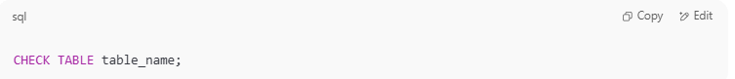
CHECK TABLE table_name;

🧪 Example:
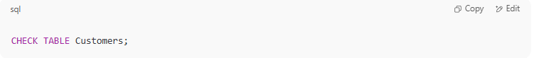
CHECK TABLE Customers;

📤 Output Example:
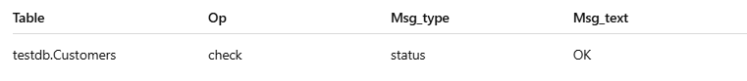
Table | Op | Msg_type | Msg_text
testdb.Customers | check | status | OK
✅ If the output is "OK", the table is fine. If not, you may need to repair it.

output CHECK TABLE Customers;
# Source: AI Source: Provided by: [Data Path: Persons Table -> ID Column: 1, Name_En Column: Motasem Essam] -> From: [ChatGPT] on [6/11/2026]
This checks the integrity of the table (mostly useful for MyISAM engine).
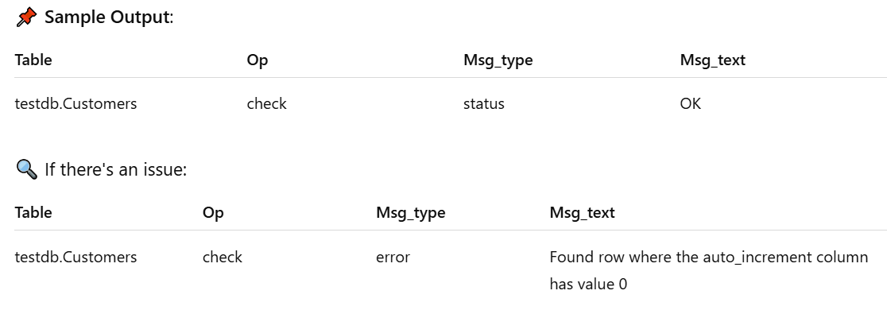
📌 Sample Output:
Table | Op | Msg_type | Msg_text
testdb.Customers | check | status | OK
🔍 If there's an issue:
Table | Op | Msg_type | Msg_text
testdb.Customers | check | error | Found row where the auto_increment column has value 0

🔹 2. OPTIMIZE TABLE
# Source: AI Source: Provided by: [Data Path: Persons Table -> ID Column: 1, Name_En Column: Motasem Essam] -> From: [ChatGPT] on [6/11/2026]
✅ Purpose:
Reorganize data and index pages to reclaim unused space and improve performance.
🔧 Syntax:
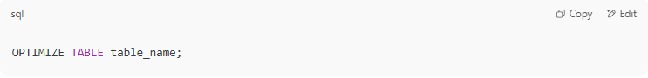
OPTIMIZE TABLE table_name;

🧪 Example:
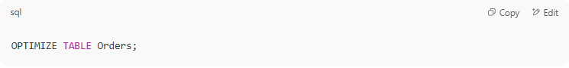
OPTIMIZE TABLE Orders;

📝 Notes:
- Effective after DELETE operations.
- Rebuilds InnoDB tables internally.
- Updates index statistics.

output OPTIMIZE TABLE Customers
# Source: AI Source: Provided by: [Data Path: Persons Table -> ID Column: 1, Name_En Column: Motasem Essam] -> From: [ChatGPT] on [6/11/2026]
This reclaims unused space and defragments data (InnoDB & MyISAM).
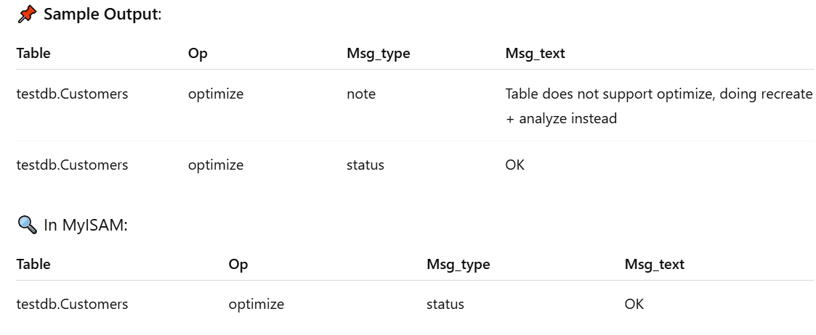
📌 Sample Output:
Table | Op | Msg_type | Msg_text
testdb.Customers | optimize | note | Table does not support optimize, doing recreate + analyze instead
testdb.Customers | optimize | status | OK
🔍 In MyISAM:
Table | Op | Msg_type | Msg_text
testdb.Customers | optimize | status | OK

🔹 3. REPAIR TABLE
# Source: AI Source: Provided by: [Data Path: Persons Table -> ID Column: 1, Name_En Column: Motasem Essam] -> From: [ChatGPT] on [6/11/2026]
✅ Purpose:
Fix corrupted tables (⚠️ works only for MyISAM tables).
🔧 Syntax:
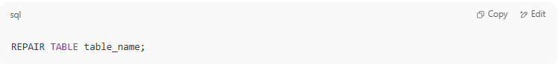
REPAIR TABLE table_name;

🧪 Example:
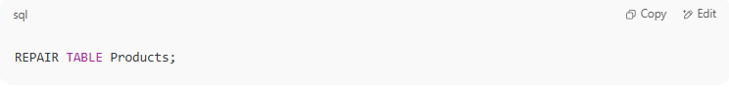
REPAIR TABLE Products;

⚠️ Warning:
- Does not work for InnoDB tables.
- Use only when CHECK TABLE reports issues.

output REPAIR TABLE Customers;
# Source: AI Source: Provided by: [Data Path: Persons Table -> ID Column: 1, Name_En Column: Motasem Essam] -> From: [ChatGPT] on [6/11/2026]
Only applies to MyISAM tables (InnoDB doesn't support it). Repairs corrupted indexes or data files.
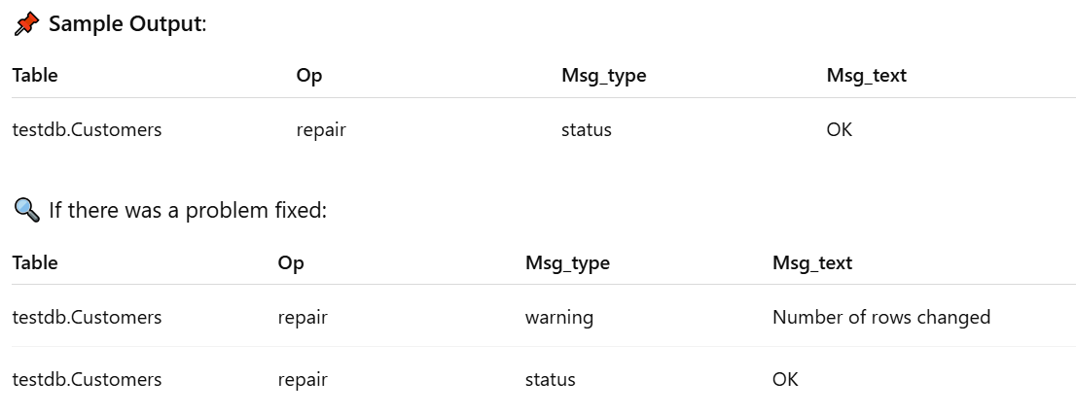
📌 Sample Output:
Table | Op | Msg_type | Msg_text
testdb.Customers | repair | status | OK
🔍 If there was a problem fixed:
Table | Op | Msg_type | Msg_text
testdb.Customers | repair | warning | Number of rows changed
testdb.Customers | repair | status | OK

📘 Summary Table
# Source: AI Source: Provided by: [Data Path: Persons Table -> ID Column: 1, Name_En Column: Motasem Essam] -> From: [ChatGPT] on [6/11/2026]
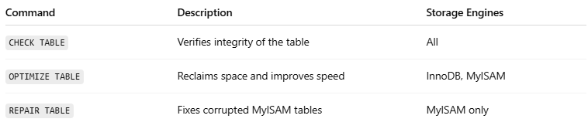
Command | Description | Storage Engines
CHECK TABLE | Verifies integrity of the table | All
OPTIMIZE TABLE | Reclaims space and improves speed | InnoDB, MyISAM
REPAIR TABLE | Fixes corrupted MyISAM tables | MyISAM only

🧠 Tip:
# Source: AI Source: Provided by: [Data Path: Persons Table -> ID Column: 1, Name_En Column: Motasem Essam] -> From: [ChatGPT] on [6/11/2026]
You can combine these commands with scripts to automate database maintenance.

Example

prepared commands
# Source: ScreenShot Source: Provided by: [Persons Table -> ID Column: 1, Name_En Column: Motasem Essam] -> Tool: [Automation Table -> ID Column: 16, Name_En Column: Screen Capture] -> From [Operating System: Wampserver64 -> phpmyadmin] on [6/11/2026]
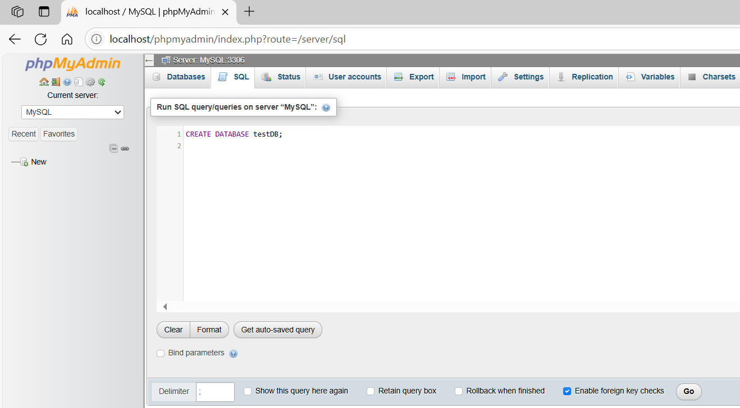
CREATE DATABASE testDB;
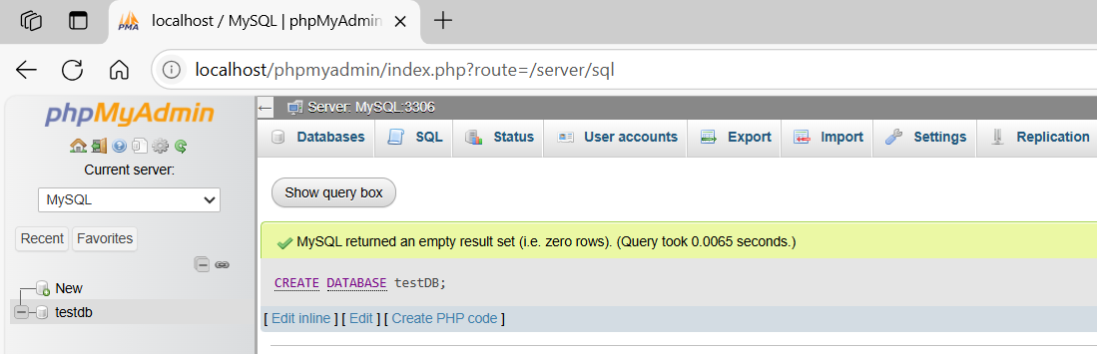
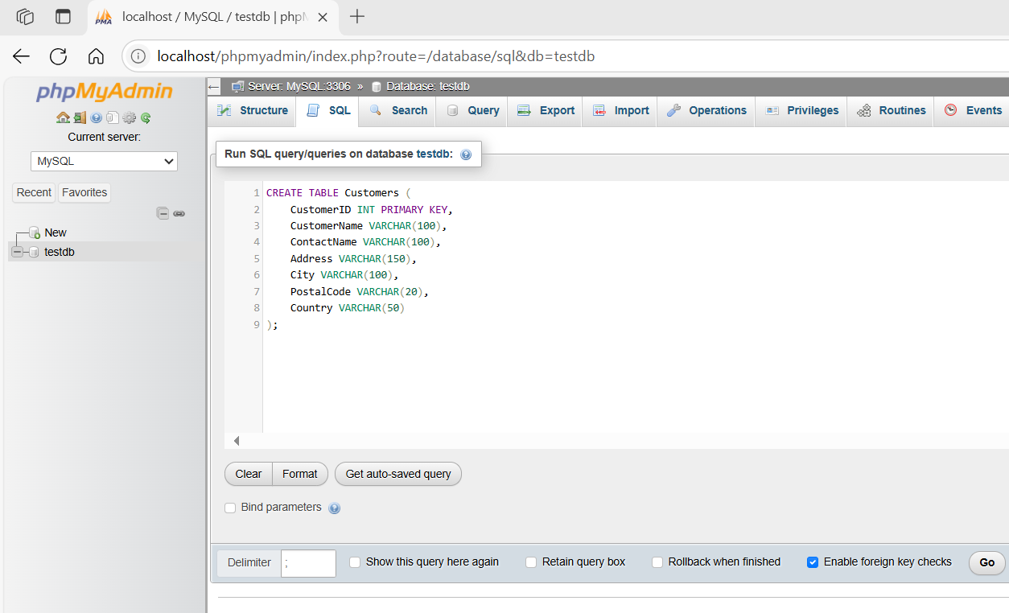
CREATE TABLE Customers (
CustomerID INT PRIMARY KEY,
CustomerName VARCHAR(100),
ContactName VARCHAR(100),
Address VARCHAR(150),
City VARCHAR(100),
PostalCode VARCHAR(20),
Country VARCHAR(50)
);
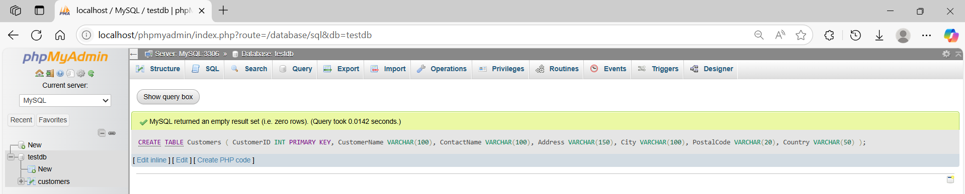

basic command
# Source: ScreenShot Source: Provided by: [Persons Table -> ID Column: 1, Name_En Column: Motasem Essam] -> Tool: [Automation Table -> ID Column: 16, Name_En Column: Screen Capture] -> From [Operating System: Wampserver64 -> phpmyadmin] on [6/11/2026]
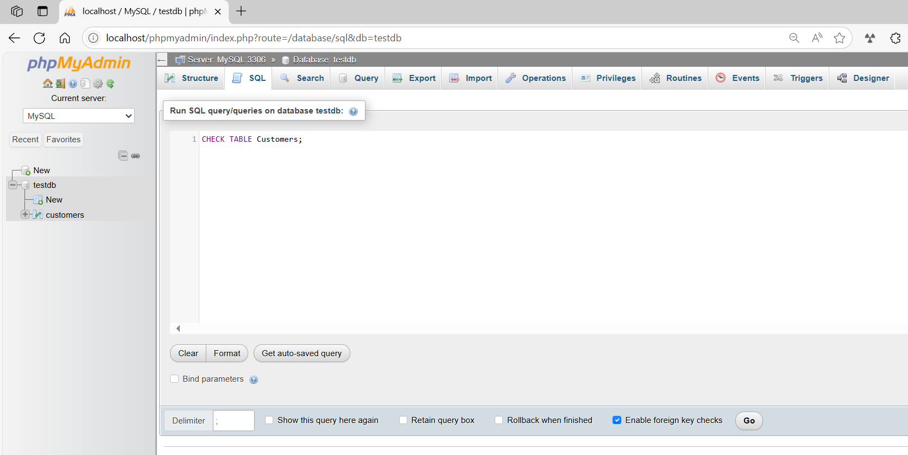
CHECK TABLE Customers;
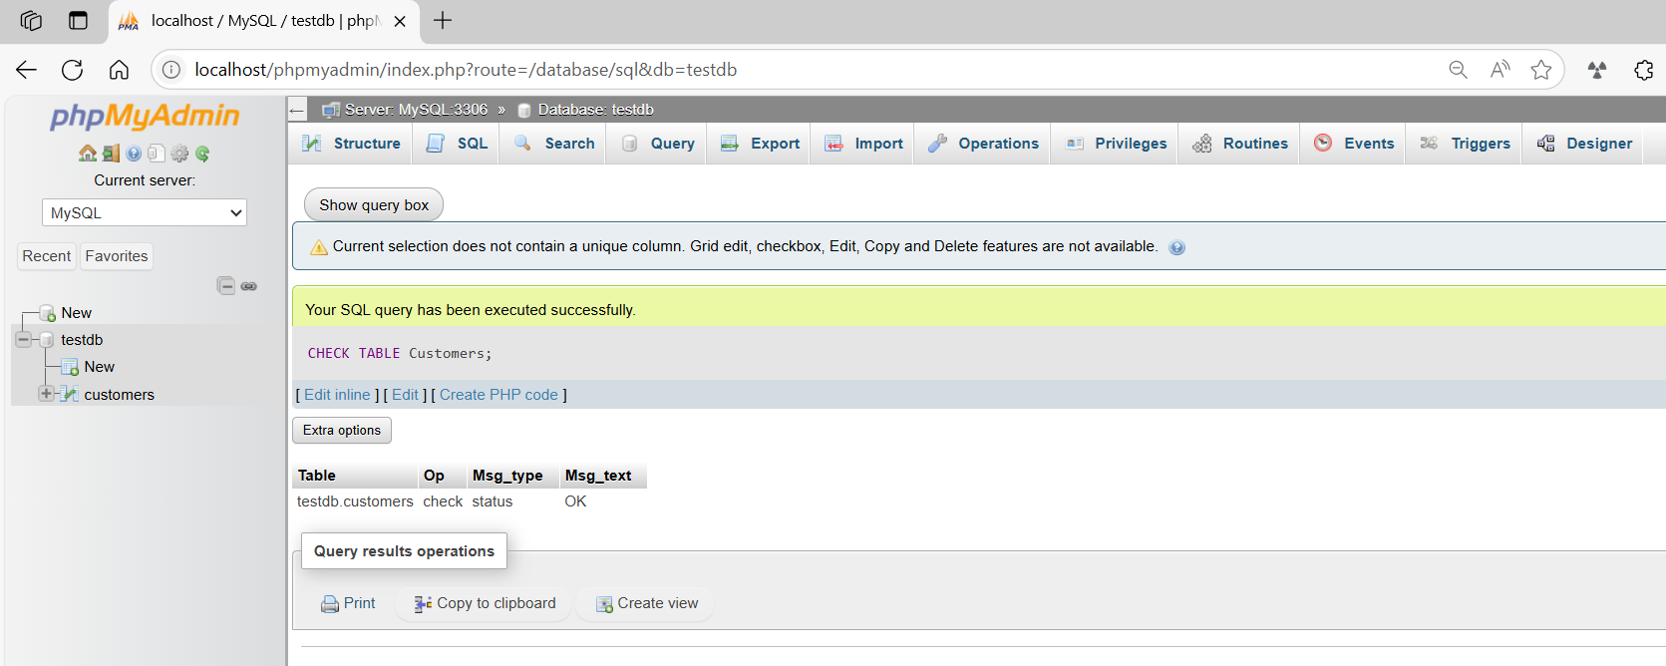
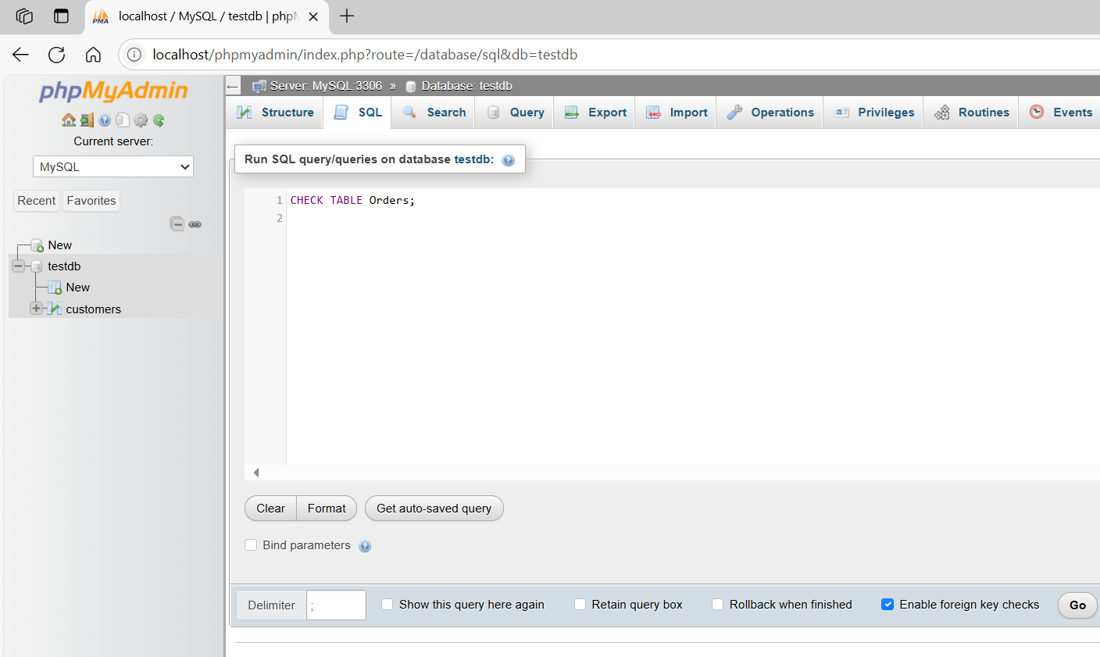CHECK TABLE Orders;
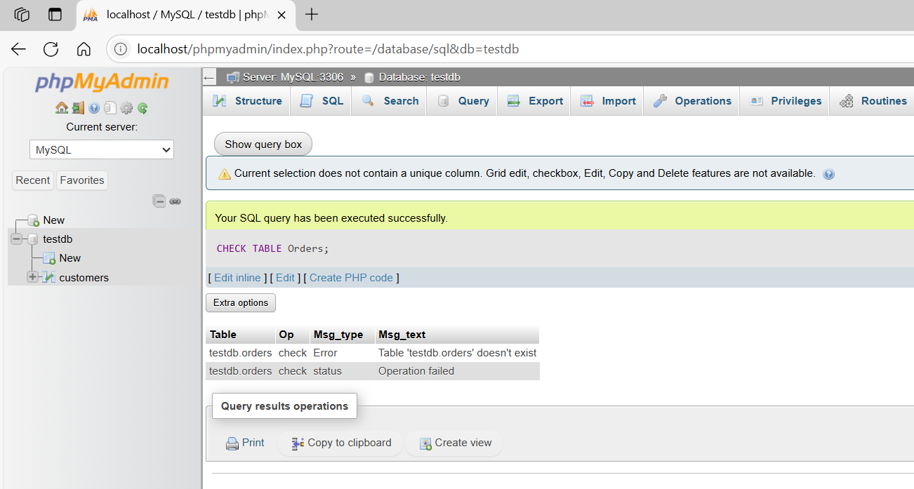

basic command
# Source: ScreenShot Source: Provided by: [Persons Table -> ID Column: 1, Name_En Column: Motasem Essam] -> Tool: [Automation Table -> ID Column: 16, Name_En Column: Screen Capture] -> From [Operating System: Wampserver64 -> phpmyadmin] on [6/11/2026]
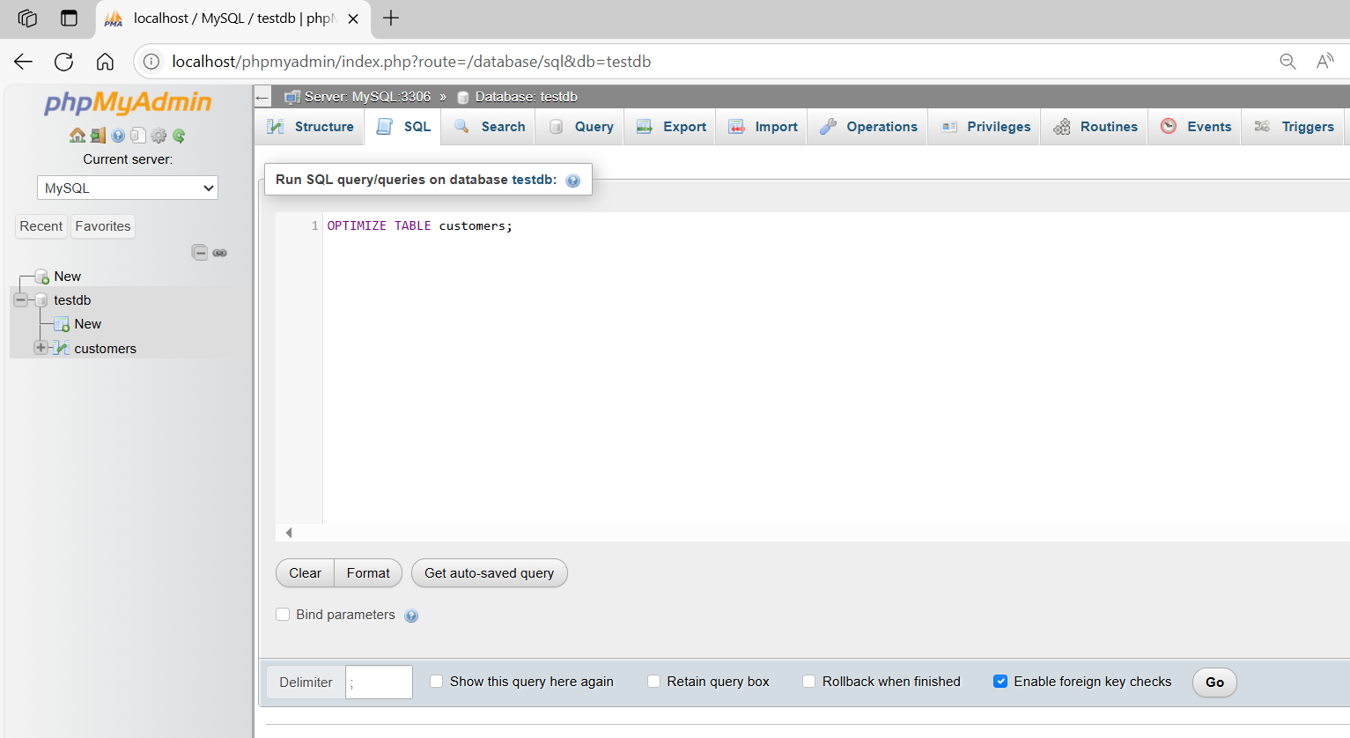
OPTIMIZE TABLE customers;
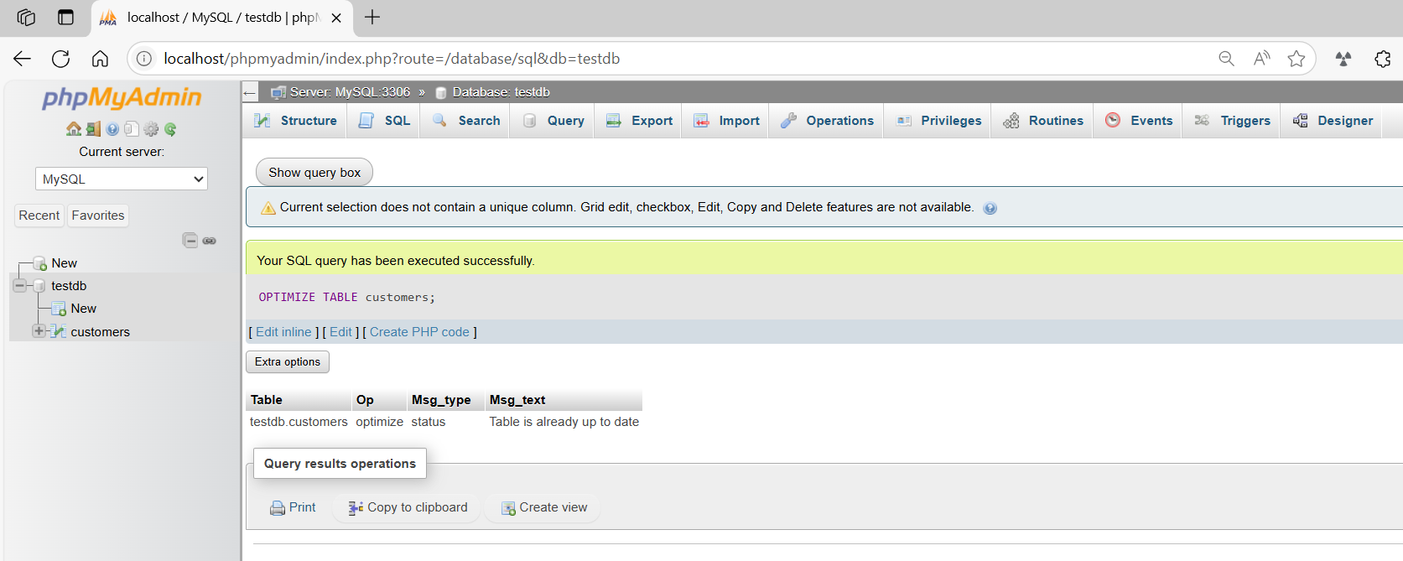
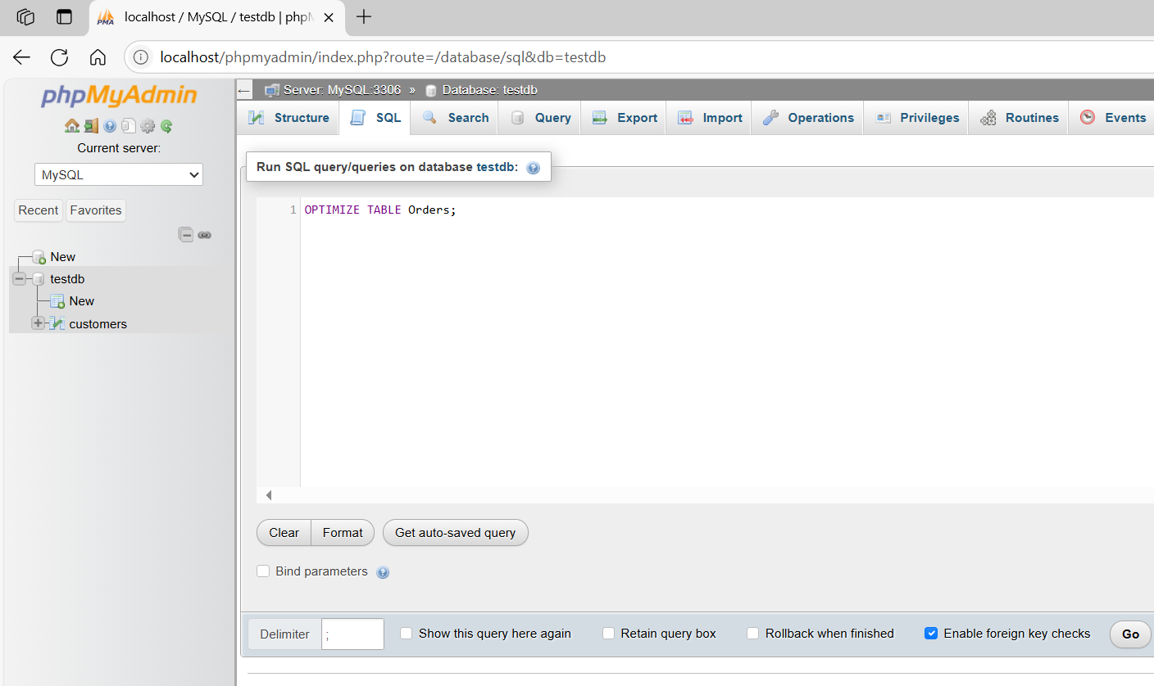
OPTIMIZE TABLE Orders;
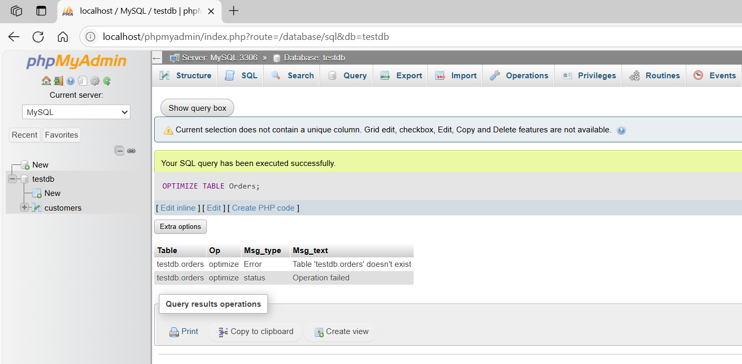

basic command
# Source: ScreenShot Source: Provided by: [Persons Table -> ID Column: 1, Name_En Column: Motasem Essam] -> Tool: [Automation Table -> ID Column: 16, Name_En Column: Screen Capture] -> From [Operating System: Wampserver64 -> phpmyadmin] on [6/11/2026]
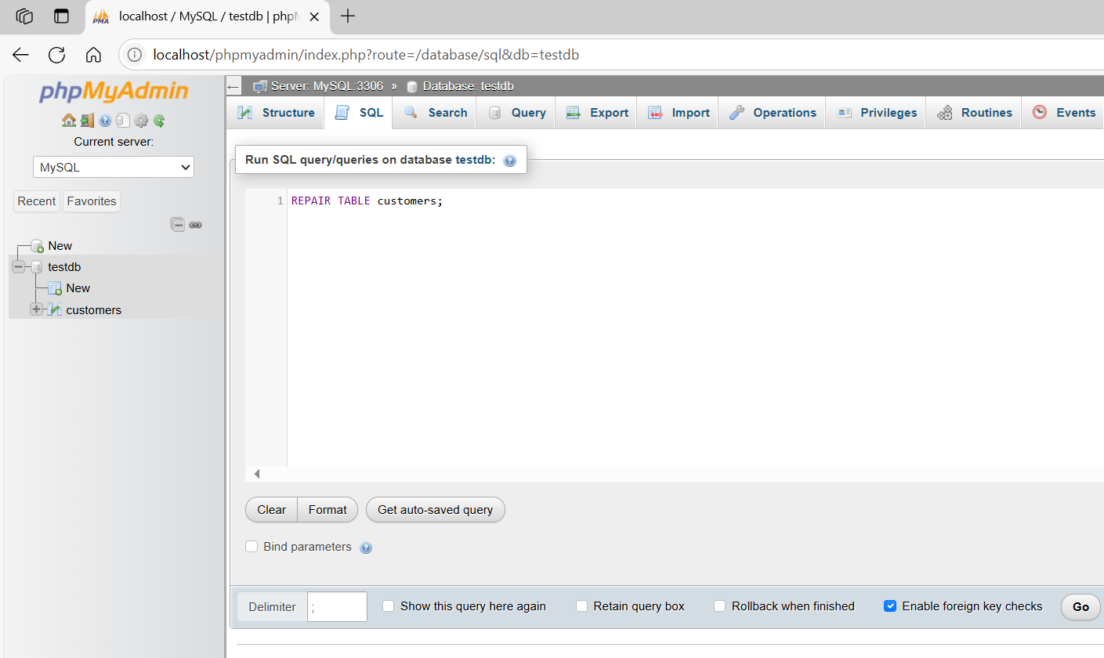
REPAIR TABLE customers;
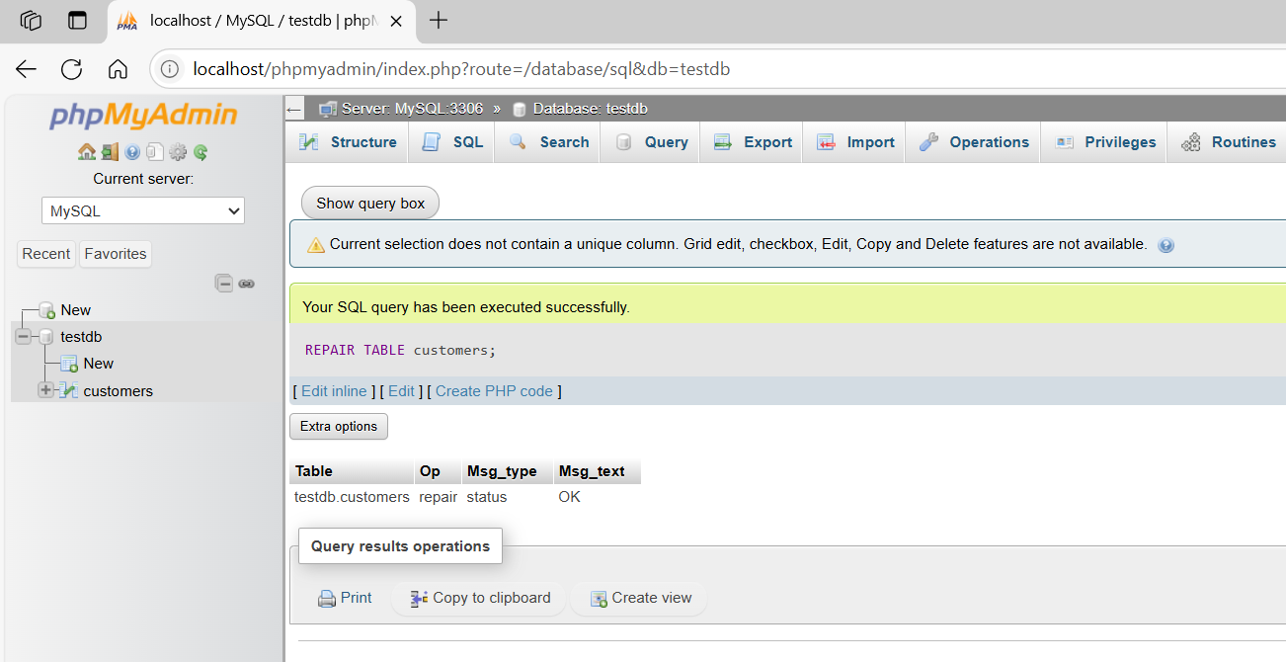
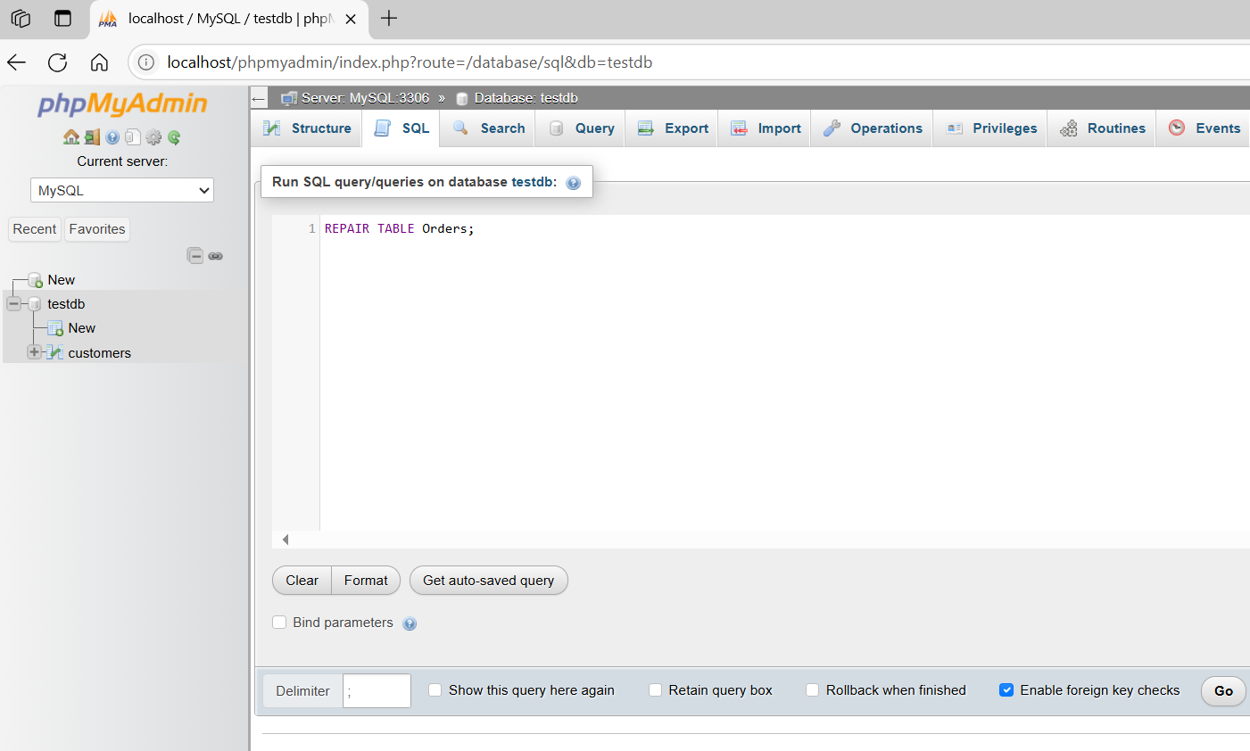
REPAIR TABLE Orders;
